Health & Social Care

Dear Colleagues,
Paper 3/2018: Health & Social Care
Last year, the CPF published a discussion paper on the important subject of adult social care. That was interrupted by the snap general election, during which the debate moved on significantly. This paper picks up and widens that discussion.
As always, discussions will be more greatly informed if groups are able to include members from different age groups. If your CPF Group does not usually include many members aged under 40, then we would encourage you to use this opportunity to reach out to younger voters in your constituency.
Please advertise the CPF paper on your Facebook and Twitter pages and encourage participation of non-members as well. It would be great if you could post a photo online of your meeting too. Let people know that you are interested in them and want to understand their perspective.
We want to ensure that as many associations and as many members are able to engage in this vital and wide-ranging discussion. Some groups may wish to discuss the questions over the course of two meetings. The closing date for this brief is therefore 31 August.
Please send your responses to the paper, via CPF.Papers@conservatives.com, using the associated response form published alongside this paper in the News section of the CPF website.
A summary of responses to this paper will be sent to the Secretary of State for Health & Social Care, the Rt Hon Jeremy Hunt MP; CPF Chairman, George Freeman MP; Conservative Vice-Chairman for Policy, Chris Skidmore MP; and the Prime Minister’s Policy Unit within a month of the closing date for submissions.
The next paper will be on the challenge and opportunities of the digital age and will be published at the start of September. Thank you. We look forward to hearing your ideas on this important topic.
The CPF Team
www.conservativepolicyforum.com
@ConservativePF

One Page Summary
“How we care for our most vulnerable citizens is the true litmus test of whether we are a civilised society – not only the care for older people but for younger disabled people who are living much longer.” (The Rt Hon Jeremy Hunt MP, Secretary of State for Health & Social Care)
Introduction
In general, the UK health system achieves superior performance compared to other countries in all areas except Health Care Outcomes.
The Challenge
More money is being put into the NHS than ever before, yet the population is growing, health costs are constantly increasing, more expensive treatments are continually becoming available, problems such as dementia and diabetes are becoming increasingly widespread, and local council budgets remain under pressure.
How Other Countries Fund Their Health & Social Care
Questions for discussion
- How has your experience of access and care in the NHS changed in recent years?
- Given the profoundly different landscape of 21st-century healthcare compared to when the NHS was founded 70 years ago, what should the role of the state be?
- What more could be done to support individuals and families to take more control of their own health and wellbeing? How might we shift from a system based on treatment to prevention of disease?
- How might we help people to use the NHS responsibly, e.g. not attending A&E for issues that a GP or pharmacy can clearly resolve? How might we reduce the costs associated with the 1-in-15 patients who miss their appointments?
- How could we further raise awareness and tackle the stigma associated with mental ill health?
- What kinds of NHS services do you think could be put online/digital rather than traditional face-to-face?
- What more could the NHS do to encourage people to want to work for it? What sorts of practices do you associate with really good employers in other sectors, which the NHS should adopt?
- How might we continue to fund sustainably a growing NHS?
- As the NHS budget grows, what health services or treatment areas should be prioritised?
- What could be done to raise awareness among working age adults about the risks of future care costs? How should we fund the need for increased social care?
- What should be the guiding principles for Conservatives in making these decisions?
- Is there any other question you think should have been asked or observation you would like to make?
The Conservative Track Record
Labour’s Record of Failure
International Case Study: Singapore
Appendix: Facts and Figures
What Our Manifesto Said

Introduction
“How we care for our most vulnerable citizens is the true litmus test of whether we are a civilised society – not only the care for older people but for younger disabled people who are living much longer.” (The Rt Hon Jeremy Hunt MP, Secretary of State for Health & Social Care, 20 March 2018)
We should begin by affirming that the Conservatives are absolutely committed to a world-class National Health Service that is free at the point of use both now and in the future. It was, after all, a Conservative Health Minister, Henry Willink, who originally set out the principles of the NHS, four years before its eventual launch on 5 July 1948.
Today the NHS is said to outperform other international health systems, thanks to its cost effectiveness and accessibility to all. This is to be celebrated, yet more improvement is needed: “the U.K. achieves superior performance compared to other countries in all areas except Health Care Outcomes, where it ranks 10th despite experiencing the fastest reduction in deaths amenable to health care in the past decade” (see Appendix). Yet, compared to the average for Europe, cancer survival rates are lower in the UK for all types of cancer—including bowel, lung, breast, ovarian, prostate and kidney cancer—except for skin melanomas.
The Challenge
More money is being put into the NHS than ever before, yet the population is growing, health costs are constantly increasing, more expensive treatments are continually becoming available, problems such as dementia and diabetes are becoming increasingly widespread, and local council budgets remain under pressure. Meanwhile our valued NHS staff have never worked harder under greater pressure.
These challenges are felt the world over, by all countries. An ageing society means that we need to reach a longer-term sustainable settlement for health and social care—both in terms of more funding and driving up the quality of services. This is why the Government has announced a long-term funding plan for the NHS and is committed to publishing a Green Paper by the summer setting out its proposals for consultation and reform.
On the NHS, the Prime Minister said that “We have to recognise for the NHS to plan and manage effectively, we need to get away from the annual top-ups to the budget we have seen. We do need to have a sustainable long-term plan.” The Government will therefore provide a multi-year funding settlement “to ensure that the NHS can cope with rising demand.”
On social care, the Prime Minister has been clear that the Green Paper will include proposals to place a limit on the care costs individuals face. The Health Secretary has set out seven principles for social care reform:¹
- quality and safety embedded in service provision;
- whole-person, integrated care with the NHS and social care systems operating as one;
- the highest possible control given to those receiving support;
- a valued workforce;
- better practical support for families and carers;
- a sustainable funding model for social care supported by a diverse, vibrant and stable market;
- greater security for all – for those born or developing a care need early in life and for those entering old age who do not know what their future care needs may be.
How Other Countries Fund Their Health & Social Care
Although the UK was the first, most western countries provide some version of universal healthcare cover, free at the point of use. The NHS is unique though in its low level of cost sharing. Of nine international health systems profiled by The Kings Fund, including universal systems that are considered comprehensive such as Sweden and France, all charge users fees. These include co-payments for each visit to a health professional, a per day charge for hospital stays, prescription co-pays, deductibles or coinsurance whereby individuals cover a set proportion of their health care costs. In addition to raising revenue, user charges in other countries can be used to manage levels of demand, the location of care or choice of treatment/drug.
Questions for discussion
- How has your experience of access and care in the NHS changed in recent years?
- Given the profoundly different landscape of 21st-century healthcare compared to when the NHS was founded 70 years ago, what should the role of the state be?
- What more could be done to support individuals and families to take more control of their own health and wellbeing? How might we shift from a system based on treatment to prevention of disease?
- How might we help people to use the NHS responsibly, e.g. not attending A&E for issues that a GP or pharmacy can clearly resolve? How might we reduce the costs associated with the 1-in-15 patients who miss their appointments?
- How could we further raise awareness and tackle the stigma associated with mental ill health?
- What kinds of NHS services do you think could be put online/digital rather than traditional face-to-face?
- What more could the NHS do to encourage people to want to work for it? What sorts of practices do you associate with really good employers in other sectors, which the NHS should adopt?
- How might we continue to fund sustainably a growing NHS?
- As the NHS budget grows, what health services or treatment areas should be prioritised?
- What could be done to raise awareness among working age adults about the risks of future care costs? How should we fund the need for increased social care?
- What should be the guiding principles for Conservatives in making these decisions?
- Is there any other question you think should have been asked or observation you would like to make?
The Conservative Track Record
Investment
- Since 2010, we have increased NHS spending in real terms each and every year.
- Our NHS has £14.4 billion more to spend on caring for people than it did in 2010, and this will reach £16 billion more by 2020-21.
- GP funding has increased by £1.9 billion since 2010, and will rise by a further £1.9 billion a year by 2020-21.
- We are investing more in mental health than ever before: a record £11.6 billion in 2016/17, with a further £1 billion on top of this by 2020/21.
- We are also investing an additional £1.4 billion in children’s mental health by 2020-21. This will improve access to mental health services for children and young people and will treat 70,000 extra children a year.
Staffing
- There are over 42,400 more clinical staff looking after patients than in 2010, including over 14,700 more doctors, 13,100 more nurses and 12,400 more midwives.
- In 2017 we provided the highest number of trainee GPs (3,157) and are providing a record number of 3,250 GP training places.
- Recent proposals set out wage rises of at least 6.5 per cent for over 1.1 million NHS workers in England. This is part of a £4.2 billion deal, averaging £1.4 billion per year.
Mental Health
- We legislated for parity of esteem between mental and physical health to make sure that there is equal priority.
- We introduced the first ever waiting time standards for mental health, bringing them into line with other NHS services.
- We are rolling out Mental Health First Aid training to every secondary school in the country by 2020. Schools will receive advice on how to deal with issues such as depression and anxiety, suicide and psychosis, self-harm, and eating disorders.
- More than two million public sector workers will receive unprecedented mental health support.
- In May 2018 Professor Sir Simon Wessely published the interim findings of his review into the Mental Health Act. The review is tackling the longstanding injustices of discrimination and rapidly rising detentions in our mental health system.
Outcomes
- In 2016-17, 23.4 million people went to A&E, 2.9 million more than in 2010.
- There were 11.9 million operations, 2.2 million more than in 2010.
- Overall, the NHS is seeing 1,800 more patients within the four-hour standard every single day compared to 2010.²²
- Around 1,400 more people are already accessing mental health services every day compared to 2010.
- 1.9 million people seen by a specialist for suspected cancer, 973,000 more than 2010.
- 290,000 patients started treatment for cancer, 57,000 more than in 2010.²⁵
- Cancer survival rates are at a record high, with over two thousand more people surviving cancer every year, over seven thousand more people estimated last year to be surviving cancer after NHS treatment compared with three years earlier, and with more people accessing cancer testing and funding for new, effective drug treatments and diagnostics.
Labour’s Record of Failure
- The total bill for NHS PFI contracts signed under Labour is a little less than £80 billion. Of this total, Labour only paid off £5.9 billion (7 per cent) whilst they were in power, leaving a total PFI bill of £75 billion. The vast majority of the NHS PFI deals were signed under a Labour government.
- Labour cut NHS funding in Wales by 8.6 per cent in real terms.
International Case Study: Singapore
In Singapore, the Government encourages greater involvement in the care of relatives through various measures:
- Aged Dependent Income Tax Relief is given to children or grandchildren for the maintenance of their parents or grandparents.
- Grandparent Caregiver Tax Relief enables working mothers whose child is being cared for by his or her grandparents to claim annual tax relief of S$3,000.
- The Maintenance of Parents Act (passed in 1995) is a preventive policy to ensure that children provide financial support for their aged parents.
- The Multi-Tier Family Housing Scheme encourages co-residence by giving priority allocation for public housing to extended-family applications.
- The Joint Selection Scheme encourages close-proximity living of the generations by allowing parents and married children to have priority in selecting separate public flats in the same estate.
- The Central Provident Fund (CPF) Housing Grant is available to married first-time applicants who buy a resale flat from the open market near their parents’ house.
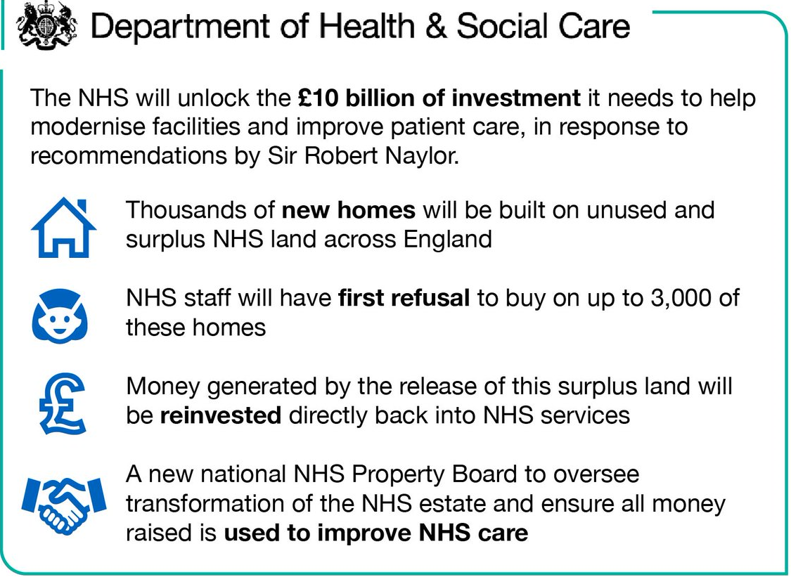

Appendix: Facts and Figures
Table: Health Care System Performance Rankings (see introduction)
 | AUS | CAN | FRA | GER | NETH | NZ | NOR | SWE | SWIZ | UK | US
OVERALL RANKING | 2 | 9 | 10 | 8 | 3 | 4 | 4 | 6 | 6 | 1 | 11
Care Process | 2 | 6 | 9 | 8 | 4 | 3 | 10 | 11 | 7 | 1 | 5
Access | 4 | 10 | 9 | 2 | 1 | 7 | 5 | 6 | 8 | 3 | 11
Administrative Efficiency | 1 | 6 | 11 | 6 | 9 | 2 | 4 | 5 | 8 | 3 | 10
Equity | 7 | 9 | 10 | 6 | 2 | 8 | 5 | 3 | 4 | 1 | 11
Health Care Outcomes | 1 | 9 | 5 | 8 | 6 | 7 | 3 | 2 | 4 | 10 | 11

Pressures on the NHS
The UK currently ranks as the country with the highest level of obesity in Europe. More than one in four (28 per cent) adults are obese and nearly two out of three (63 per cent) overweight. More than one in five children (22 per cent) are overweight or obese in their first year of primary school in England. This increases to more than one in three (34 per cent) by the time they leave primary school.
The number of people diagnosed with diabetes in the UK has more than doubled in the last twenty years. Over the next 20 years, the number of obese adults in the country is forecast to soar to 26 million people. Such a rise could result in more than a million extra cases of type-2 diabetes, heart disease and cancer.³⁰
Over the last 65 years, life expectancy has increased by 12.8 years for men and 11.4 years for women, to 79.2 and 82.9 years, respectively. Disability-free life expectancy is rising more slowly than life expectancy, however, meaning that people are living for more years with disabilities. Moreover, the gender difference in life expectancy suggests that most of the extra years of life for women are years with disability or ill-health.
The effect of this population shift on health and social care services is significant. Every five years after the age of 65 the risk of developing dementia doubles. It is estimated that 850,000 people in the UK were living with dementia in 2015, with numbers set to rise to over 1 million by 2025. People with long-term conditions account for 29 per cent of the population, but use 70 per cent of all inpatient bed days. Over-75s use more than 60 per cent of bed days in acute hospitals and 70 per cent of the health and social care budget is spent on chronic conditions.
More than a million older people in England now have at least one unmet need for social care, compared to 800,000 in 2010; this means they receive no help from their local authority or from family, neighbours or friends. It would cost an extra £4.7 billion in 2020/21 to provide a social care service to every older person with an unmet social care need, and only a little less to provide a service for those with three or more currently unmet needs. Social isolation and chronic loneliness have a significant impact on health and wellbeing, increasing the use of health and adult social care services by older people.
Just over 1-in-10 (10.9 per cent) patients who go to A&E are discharged without needing treatment, while almost 2-in-5 (38.9 per cent) are given “guidance or advice” only.
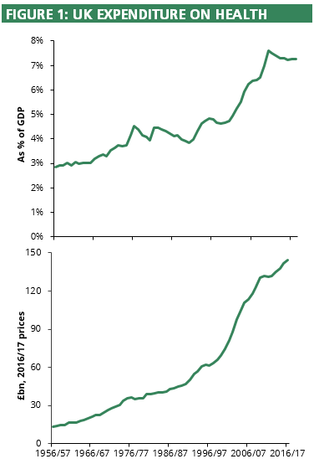
Health cost and performance in the devolved administrations
UK expenditure on health (see figure 1) has risen rapidly and consistently since the NHS was established, from £11.4bn (~£228 per person) to over £144.3bn.
In 2016/17 health services expenditure per head was highest in Scotland (£2,332 per head) and lowest in England (£2,169 per head); cf. Wales: £2,233 per head and N.Ireland: £2,240 per head. Growth in health expenditure has far outpaced the rise in both GDP and total public expenditure.
Recent analysis suggests that UK spending on healthcare will have to rise by an average 3.3 per cent a year over the next 15 years just to maintain NHS provision at current levels, and by at least 4 per cent a year if services are to be improved. Social care funding will need to increase by 3.9 per cent a year to meet the needs of an ageing population and an increasing number of younger adults living with disabilities.
Life expectancy is higher in England than Wales or Scotland and in recent years the gap between England and both other countries has increased.
In August 2017, 2.2% of patients in England waited over 6 weeks for diagnostic tests. This compares with 17.1% in Scotland (figures for June 2017) and 22.1% in Wales.
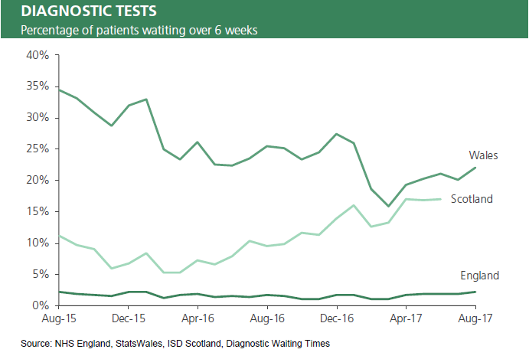
What Our Manifesto Said
Theresa May’s Conservatives will deliver … Exceptional healthcare, whenever, wherever, delivered by an NHS with the money, buildings and people it needs. (p.62)
If we want to overcome Britain’s enduring social divisions, we will need to give people real opportunity and make Britain the world’s Great Meritocracy. That will require government to take on long-ignored problems like Britain’s lack of training and technical education, as well as long-lasting injustices, such as the lack of care for people with mental health problems, and the inequality of opportunity that endures on the basis of race, gender and class.
If we are going to cope with our ageing society and if we want to give security to people in old age while being fair to younger generations, we are going to need positive, active government that will deal with increased demand for social care, fund and improve our National Health Service and build more houses across the country. We will need to take sometimes difficult decisions that ask more of one generation in order to help another.” (pp.8-9)
The mental health gap
It was Conservatives in government that gave parity of esteem to the treatment of mental health in the National Health Service. We have backed this with a significant increase in funding: since 2010 we have increased spending on mental health each year to a record £11.4 billion in 2016/17, with a further investment of £1 billion by 20/21, so that we can deliver the mental health services people deserve. We will now build on this commitment.
First, we will address the need for better treatments across the whole spectrum of mental health conditions. We will make the UK the leading research and technology economy in the world for mental health, bringing together public, private and charitable investment.
Improving treatment services will not be sufficient, however. We will also reform outdated laws to ensure that those with mental illness are treated fairly and employers fulfil their responsibilities effectively.
The current Mental Health Act does not operate as it should: if you are put on a community treatment order it is very difficult to be discharged; sectioning is too often used to detain rather than treat; families’ information about their loved ones is severely curtailed – parents can be the last to learn that their son or daughter has been sectioned. So we will introduce the first new Mental Health Bill for thirty-five years, putting parity of esteem at the heart of treatment.
We will transform how mental health is regarded in the workplace. We will amend health and safety regulations so that employers provide appropriate first aid training and needs assessment for mental health, as they currently do for risks to physical health, and extend Equalities Act protections against discrimination to mental health conditions that are episodic and fluctuating. We will consider the findings of the Stevenson-Farmer Review into workplace mental health support, working with employers to encourage new products and incentives to improve the mental health and wellbeing support available to their employees. And, as we did with Dementia Friends, we will train one million members of the public in basic mental health awareness and first aid to break the stigma of mental illness. (pp.56-57)
A long-term plan for elderly care
Under the current system, care costs deplete an individual’s assets, including in some cases the family home, down to £23,250 or even less. ... We intend to tackle this with three connected measures.
First, we will align the future basis for means-testing for domiciliary care with that for residential care, so that people are looked after in the place that is best for them. This will mean that the value of the family home will be taken into account along with other assets and income, whether care is provided at home, or in a residential or nursing care home.
Second, to ensure this is fair, we will introduce a single capital floor, set at £100,000, more than four times the current means test threshold. This will ensure that, no matter how large the cost of care turns out to be, people will always retain at least £100,000 of their savings and assets, including value in the family home.
Third, we will extend the current freedom to defer payments for residential care to those receiving care at home, so no-one will have to sell their home in their lifetime to pay for care. We believe this powerful combination maximises protection for pensioner households with modest assets, often invested in the family home, while remaining affordable for taxpayers. We consider it more equitable, within and across the generations, than the proposals following the Dilnot Report, which mostly benefited a small number of wealthier people.
An efficient elderly care system which provides dignity is not merely a function of money. So our forthcoming green paper will also address system-wide issues to improve the quality of care and reduce variation in practice. This will ensure the care system works better with the NHS to reduce unnecessary and unhealthy hospital stays and delayed transfers of care, and provide better quality assurance within the care sector. We will reduce loneliness and promote technological solutions to prolong independent living, and invest in dementia research. As the majority of care is informally provided, mainly by families, we will give workers a new statutory entitlement to carer’s leave, as enjoyed in other countries. (p.65)
OUR NATIONAL HEALTH SERVICE
Our National Health Service is the essence of solidarity in our United Kingdom – our commitment to each other, between young and old, those who have and those who do not, and the healthy and the sick.
The Conservative Party believes in the founding principles of the NHS. First, that the service should meet the needs of everyone, no matter who they are or where they live. Second, that care should be based on clinical need, not the ability to pay. Third, that care should be free at the point of use. As the NHS enters its eighth decade, the next Conservative government will hold fast to these principles by providing the NHS with the resources it needs and holding it accountable for delivering exceptional care to patients wherever and whenever they need it.
The money and people the NHS needs
In five ways, the next Conservative government will give the NHS the resources it needs. First, we will increase NHS spending by a minimum of £8 billion in real terms over the next five years, delivering an increase in real funding per head of the population for every year of the parliament.
Second, we will ensure that the NHS and social care system have the nurses, midwives, doctors, carers and other health professionals that it needs. We will make it a priority in our negotiations with the European Union that the 140,000 staff from EU countries can carry on making their vital contribution to our health and care system. However, we cannot continue to rely on bringing in clinical staff instead of training sufficient numbers ourselves. Last year we announced an increase in the number of students in medical training of 1,500 a year; we will continue this investment, doing something the NHS has never done before, and train the doctors our hospitals and surgeries need.
Third, we will ensure that the NHS has the buildings and technology it needs to deliver care properly and efficiently. Since its inception, the NHS has been forced to use too many inadequate and antiquated facilities, which are even more unsuitable today. We will put this right and enable more care to be delivered closer to home, by building and upgrading primary care facilities, mental health clinics and hospitals in every part of England. Over the course of the next parliament, this will amount to the most ambitious programme of investment in buildings and technology the NHS has ever seen.
Fourth, whilst the NHS will always treat people in an emergency, no matter where they are from, we will recover the cost of medical treatment from people not resident in the UK. We will ensure that new NHS numbers are not issued to patients until their eligibility has been verified. And we will increase the Immigration Health Surcharge, to £600 for migrant workers and £450 for international students, to cover their use of the NHS. This remains competitive compared to the costs of health insurance paid by UK nationals working or studying overseas.
Fifth, we will implement the recommendations of the Accelerated Access Review to make sure that patients get new drugs and treatments faster while the NHS gets best value for money and remains at the forefront of innovation.
Holding NHS leaders to account
It is NHS England that determines how best to organise and deliver care in England, set out in its own plan to create a modern NHS – the Five Year Forward View. We support it. We will also back the implementation of the plan at a local level, through the Sustainability and Transformation Plans, providing they are clinically led and locally supported. We will hold NHS England’s leaders to account for delivering their plan to improve patient care. If the current legislative landscape is either slowing implementation or preventing clear national or local accountability, we will consult and make the necessary legislative changes. This includes the NHS’s own internal market, which can fail to act in the interests of patients and creates costly bureaucracy. So we will review the operation of the internal market and, in time for the start of the 2018 financial year, we will make non-legislative changes to remove barriers to the integration of care.
We expect GPs to come together to provide greater access, more innovative services, share data and offer better facilities, while ensuring care remains personal – particularly for older and more vulnerable people – with named GPs accountable for individual patients. We will support GPs to deliver innovative services that better meet patients’ needs, including phone and on-line consultations and the use of technology to triage people better so they see the right clinician more quickly. We will ensure appropriate funding for GPs to meet rising costs of indemnity in the short term while working with the profession to introduce a sustainable long-term solution.
We will introduce a new GP contract to help develop wider primary care services. We will reform the contract for hospital consultants to reflect the changed nature of hospital care over the past twenty years. We shall support more integrated working, including ensuring community pharmacies can play a stronger role to keep people healthy outside hospital within the wider health system. We will support NHS dentistry to improve coverage and reform contracts so that we pay for better outcomes, particularly for deprived children. And we will legislate to reform and rationalise the current outdated system of professional regulation of healthcare professions, based on the advice of professional regulators, and ensure there is effective registration and regulation of those performing cosmetic interventions.
We will also help the million and more NHS clinicians and support staff develop the skills they need and the NHS requires in the decades ahead. We will encourage the development of new roles and create a diverse set of potential career paths for the NHS workforce. And we will reform medical education, including helping universities and local health systems work closer together to develop the roles and skills needed to serve patients.
We want the NHS to become a better employer. We will strengthen the entitlement to flexible working to help those with caring responsibilities for young children or older relatives. We will introduce new services for employees to give them the support they need, including quicker access to mental health and musculoskeletal services. We will act to reduce bullying rates in the NHS, which are far too high. We will take vigorous and immediate action against those who abuse or attack the people who work for and make our NHS.
Exceptional standards of care, wherever, whenever
Outcomes in the NHS for most major conditions are considerably better than three, five or ten years ago. However, the founding intention for the NHS was to provide good levels of care to everyone, wherever they live. This has not yet been achieved: there remain significant variations in outcomes and quality across services and across the country. We will act to put this right.
To help the NHS provide exceptional care in all parts of England, we will make clinical outcomes more transparent so that clinicians and frontline staff can learn more easily from the best units and practices, and where there is clear evidence of poor patient outcomes, we will take rapid corrective action. We will ensure patients have the information they need to understand local services and hold them to account. We will empower patients, giving them a greater role in their own treatment and use technology to put care at their convenience. In addition to the digital tools patients already have, we will give patients, via digital means or over the phone, the ability to book appointments, contact the 111 service, order repeat prescriptions, and access and update aspects of their care records, as well as control how their personal data is used.
We will continue to expand the number of NHS approved apps that can help monitor care and provide support for physical and mental health conditions. We will pilot the live publication of waiting times data for A&Es and other urgent care services. We will further expand the use of personal budgets. We will also continue to take action to reduce obesity and support our National Diabetes Prevention Programme.
Our ambition is also to provide exceptional care to patients whenever they need it. That is why we want England to be the first nation in the world to provide a truly seven-day healthcare service. That ambition starts with primary care. Already 17 million people can get routine weekend or evening appointments at either their own GP surgery or one nearby, and this will expand to the whole population by 2019.
In hospitals, we will make sure patients receive proper consultant supervision every day of the week with weekend access to the key diagnostic tests needed to support urgent care. We will also ensure hospitals can discharge emergency admissions at a similar rate at weekends as on weekdays, so that when someone is medically fit to leave hospital they can, whichever day of the week it is.
We will retain the 95 per cent A&E target and the 18-week elective care standard so that those needing care receive it in a timely fashion.
We will continue to help the NHS on its journey to being the safest healthcare system in the world. We will extend the scope of the CQC to cover the health-related services commissioned by local authorities. We will legislate for an independent healthcare safety investigations body in the NHS. We will require the NHS to continue to reduce infant and maternal deaths, which remain too high.
Our commitment to consistent high quality care for everyone applies to all conditions. We will set new standards in some priority areas and also improve our response to historically underfunded and poorly understood disease groups.
In cancer services, we will deliver the new promise to give patients a definitive diagnosis within 28 days by 2020, while expanded screening and a major radiotherapy equipment upgrade will help ensure many more people survive cancer.
We will continue to rectify the injustice suffered by those with mental health problems, by ensuring that they get the care and support they deserve. So we will make sure there is more support in every part of the country by recruiting up to 10,000 more mental health professionals. We shall require all our medical staff to have a deeper understanding of mental health and all trainees will get a chance to experience working in mental health disciplines; we shall ensure medical exams better reflect the importance of this area. And we will improve the co-ordination of mental health services with other local services, including police forces and drug and alcohol rehabilitation services.
We have a specific task to improve standards of care for those with learning disabilities and autism. We will work to reduce stigma and discrimination and implement in full the Transforming Care Programme.
We will improve the care we give people at the end of life. We will fulfil the commitment we made that every person should receive attentive, high quality, compassionate care, so that their pain is eased, their spiritual needs met and their wishes for their closing weeks, days and hours respected. We will ensure all families who lose a baby are given the bereavement support they need, including a new entitlement to child bereavement leave. (pp.66-70)
Children’s and young people’s health
We believe government has a role to play in helping young people get the best possible start in life. We are seeing progress: smoking rates are now lower than France or Germany, drinking rates have fallen below the European average and teenage pregnancies are at record lows. We will continue to take action to reduce childhood obesity. We will promote efforts to reduce unhealthy ingredients and provide clearer food information for consumers, as our decision to leave the European Union will give us greater flexibility over the presentation of information on packaged food. We shall continue to support school sport, delivering on our commitment to double support for sports in primary schools. We understand the massively increased pressures on young people’s mental health. We will take focused action to provide the support needed by children and young people. Half of all mental health conditions become established in people before the age of fourteen. So we will ensure better access to care for children and young people. A Conservative government will publish a green paper on young people’s mental health before the end of this year. We will introduce mental health first aid training for teachers in every primary and secondary school by the end of the parliament and ensure that every school has a single point of contact with mental health services. Every child will learn about mental wellbeing and the mental health risks of internet harms in the curriculum. And we will reform Child and Adolescent Mental Health Services so that children with serious conditions are seen within an appropriate timeframe and no child has to leave their local area and their family to receive normal treatment.
Protecting vulnerable children and families
We have made significant progress in helping vulnerable children and families over the past seven years. Our investments in the social work profession and in successful, innovative programmes have given tens of thousands of vulnerable families the coordinated support they need.
Placing a child under the oversight of social services and taking a child into care are amongst the most serious duties the state may discharge. We will demand all local authorities be commissioners of the highest-quality family support and child protection services, removing these responsibilities from the weakest councils and placing them in trust. We will ensure that councils provide consistency of care and cannot relocate vulnerable children far from their home when it is not in their best interests to do so. We will review support for Children in Need to understand why their outcomes are so poor and what more support they might require, in and out of school.
Finally, we shall explore ways to improve the family justice system. The family courts need to do more to support families, valuing the roles of mothers and fathers, while ensuring parents face up to their responsibilities. (pp.72-73)
Endnotes

Groups may wish to remind themselves of some of the issues raised in that paper: link
N.B. “That consultation will include an absolute limit on the amount people have to pay for their care costs.” (http://www.conservatives.com/socialcare)
We need to do better on social care, Department of Health and Social Care, 20 March 2018, link
MIRROR, MIRROR 2017: International Comparison Reflects Flaws and Opportunities for Better U.S. Health Care, The Commonwealth Fund, July 2017, p.5, link
Comparator report on patient access to cancer medicines in Europe revisited - A UK perspective, Association of the British Pharmaceutical Industry, 17 Jul 2017, link
NHS: PM to look at 'multi-year' funding plan for health service, BBC News, 27 March 2018, link
The social care and health systems of nine countries, The King’s Fund, 2014: link
How much money does the NHS need and how much is it actually getting?, Full Fact, 12 January 2018, link
The NHS budget and how it has changed, The King’s Fund, 14 May 2017, link
HSCIC, 19 September 2014, link; NHS Digital, 20 September 2017, link; NHS England, GP Forward View Investment, link
Mental Health Services: Finance: Written question - HL3655, Department of Health, 28 November 2017, link
Mental Health Services: Children and Young People: Written question – 125663, Department of Health and Social Care, 30 January 2018, link
NHS Workforce Statistics January 2018, NHS Digital, 24 April 2018, link
GP Recruitment 2009-13, link; GP Recruitment 2017, link
NHS Staff Pay, Hansard, 21 March 2018, link
Hansard, 9 January 2017, Vol. 619, link; Queens Speech, June 2017
Department of Health and Social Care, 14 October 2014, link
PM: mental health training for teachers will "make a real difference to children's lives", Department for Education, 27 June 2017, link
Millions to benefit from groundbreaking mental health support, Prime Minister's Office, 10 Downing Street, 26 October 2017, link
Independent Review of the Mental Health Act: Interim Report, Department of Health and Social Care, 1 May 2018, link
Community Care, 4 October 2017, link
Hospital Accident and Emergency Activity, 2016-17: Tables, NHS Digital, 17 October 2017, link
Hospital Episode Statistics 2016-17: Procedures and Interventions, NHS Digital, 3 October 2017, link; Hospital Episode Statistics 2009-10: Main Operations, NHS Digital, 28 October 2010, link
Hansard, 114730, 20 November 2017, link
Waiting Times for Suspected and Diagnosed Cancer Patients 2016-17, NHS Digital, 6 June 2017, link; Waiting Times for Suspected and Diagnosed Cancer Patients 2009-10, Department of Health, 26 November 2010, link
Next steps on the NHS Five Year Forward View: NHS action to prevent, diagnose and treat cancer means 5,000 more lives to be saved within two years, NHS England, 31 March 2017, link; NHS cancer care has never been better with over two thousand more people surviving cancer every year, NHS England, 24 December 2017, link
Private Finance Initiative and Private Finance 2 projects: 2015 summary data, HM Treasury, March 2016, link; The Daily Mail, 31 August 2017, link
Scenarios for the Welsh Budget, IFS, September 2013, link
Aging and Caring at the Intersection of Work and Home Life: Blurring the boundaries, eds. Martin-Matthews, ‎A., & Phillips, J.E., 2010
Diabetes and Obesity, Diabetes.co.uk, link
Number of people living with diabetes doubles in twenty years, Diabetes.co.uk, 27 February 2018, link
National life tables, UK: 2014 to 2016, Office for National Statistics, 27 September 2017, link; How has life expectancy changed over time? Office for National Statistics, 9 September 2015, link
Disability-Free Life Expectancy by Upper Tier Local Authority: England 2012 to 2014, Office for National Statistics, 10 March 2016, link
Trends in life expectancy and healthy life expectancy, Government Office for Science, March 2015, link
Facts for the media, Alzheimer's Society, link
Ten things you need to know about long term conditions, Department of Health, 2012, link
The Care of Frail Older People with Complex Needs: Time for a Revolution, The King’s Fund, 2012, link
The Health and Care of Older People in England 2015, Age UK, February 2016: link
Loneliness, social isolation can lead to increased health care use in older adults, News-Medical.net, 1 April 2015: link; see also Loneliness and isolation: Social relationships are key to good health, Public Health England, 8 December 2015: link
Hospital Accident and Emergency Activity, 2016-17, NHS Digital, 17 Oct 2017, link
NHS Funding and Expenditure, House of Commons Library, 13 April 2018, link
Securing the future: funding health and social care to the 2030s, Health Foundation & Institute for Fiscal Studies, 24 May 2018, link
Life Expectancy at Birth and at Age 65 by Local Areas in England and Wales: 2012 to 2014, Office for National Statistics, 4 November 2015, link; Scottish life expectancy 'still lowest in UK', BBC, 29 November 2016, link
Waiting times in England, Wales & Scotland: Social Indicators page, House of Commons Library, 27 November 2017, link

